
MALDWYN NURSERY & FAMILY CENTRE

MALDWYN NURSERY & FAMILY CENTRE
Park Lane * Newtown * Powys * SY16 1DE * Tel 01686622191
E-mail: maldwyn_nursery@outlook.com CIW No: WO 200 000 24/6
General Data Protection Regulations (GDPR) Policy
The Data Protection Act 2018 (DPA) brought in the EU’s General Data Protection Regulation (GDPR) to protect your personal data and came into effect on 25th May 2018 replacing the Data Protection Act 1998. It gives individuals greater control over their own personal data.
As a nursery it is necessary for us to collect personal information about the children who attend as well as staff and parents/carers.
Maldwyn Nursery and Family centre is registered with the Information Commissions Office, ICO, under registration reference: ZA280637 and has been registered since 28th September 2017.
GDPR Principle
GDPR condenses the Data Protection Principles into 8 areas, which are referred to as the Privacy Principles. They are:
- You must have lawful reason for collecting personal data and must do it in a fair and transparent way.
- You must only use data for the reason it is initially obtained.
- You must not collect any more data than is necessary.
- It must be accurate and there must be mechanisms in place to keep it up to date.
- You cannot keep it any longer than needed.
- You must protect the personal data.
- You must have appropriate measures against unauthorised or unlawful processing or personal data and against accidental loss or destruction/damage to personal data.
- Personal Data shall not be transferred to any outside agency or country within the EY that does not comply with the new General data protection regulations.
The GDPR provides the following rights to the individual
- The right to be informed
- The right to access
- The right to rectification
- The right to erase
- The right to restrict processing.
- The right to data portability.
- The right to object
- Rights in relation to automated decision-making and profiling.
Categories of children’s information that we collect, hold and share include:
- Personal Information (Such as name, address, date of birth)
- Characteristics (Ethnicity, language, nationality flying start eligibility)
- Attendance information
- Observations and Assessment information and tracking of progress
- Medical information
- Information on Additional Learning Needs
- Referrals to other relevant services
- Safeguarding information
We also collect, hold and share some information on the children’s parents/guardians:
- Personal information (Name, address, contact numbers and emails)
Why we collect and use this information
Support the learning and development of the child, to enable staff to plan suitable activities to extend their knowledge and skills ensure that all children are safe within our setting.
Monitor and report on their progress, Provide appropriate behavioural and emotional support as required and assess the quality of our services as a childcare provider.
Comply with the law regarding data sharing (GDPR)
Collecting children’s information
While the majority of children’s information you provide to us is mandatory, some of it is provided to us on a voluntary basis. In order to comply with GDPR, we will inform you if you are required to provide certain information to us or if you have a choice in this.
Storing children’s data
We are required to hold children’s data for a reasonable period of time after children have left the provision as a requirement. The limitation Act 1980 recommends that we retain data until the child reaches the age of 21 or until the child reaches the age of 24 for child protection records. Please see appendix 1 for more information.
Any data stored will be done so securely and only accessed by staff who have the authority to do so.
Who we share children’s information with:
We routinely share children’s information with:
- Schools that your child will be attending after leaving the provision and other local childcare providers where the child is engaging.
- Local Authority
- ALNCO co-ordinators
- NHS services (such as health visitors and speech and language therapists)
Requesting access to your personal data:
Under data protection legislation, parents and children have the right to request access to information about them that we hold. To make a request for your personal information or be given access to your child’s early years record, contact Mr Ian Hancocks who is our data protection officer.
Consent needed to share information
Maldwyn Nursery and Family Centre will always look to work with the individual from the onset and seek consent and be open and honest with the individual as to why, what, how and with whom, their information will be shared.
There however may be circumstances where it is not appropriate to seek consent, either because the individual cannot give consent, it is not reasonable to obtain consent, or because to gain consent would put a child or young person’s safety or well-being at risk.
With support from the Wales Safeguarding procedures, Maldwyn Nursery reserves the right to pass on information relating to child protection concerns without gaining prior consent depending on the situation such as if the possibility the child would be put further at risk, if a carer of family member is identified as an alleged abuser.
When a decision to share information without consent is made, a record of what has been shared should be kept.
You also have the right to:
Object to processing of personal data that is likely to cause or is causing damage or distress prevent processing for the purpose of direct marketing in certain circumstances, have in accurate personal data rectified, blocked, erased, or destroyed.
If you have a concern about the way we are collecting or using your personal data, we request that you raise your concern with us in the first instance. Alternatively, you can contact the ICO.
The ICO can be contacted at 0303 123 1113
The policy has been adopted by Maldwyn Nursery and Family Centre February 2022.
Ian Hancocks
Nursery Manager
Reviewed May 2024 Ian Hancocks
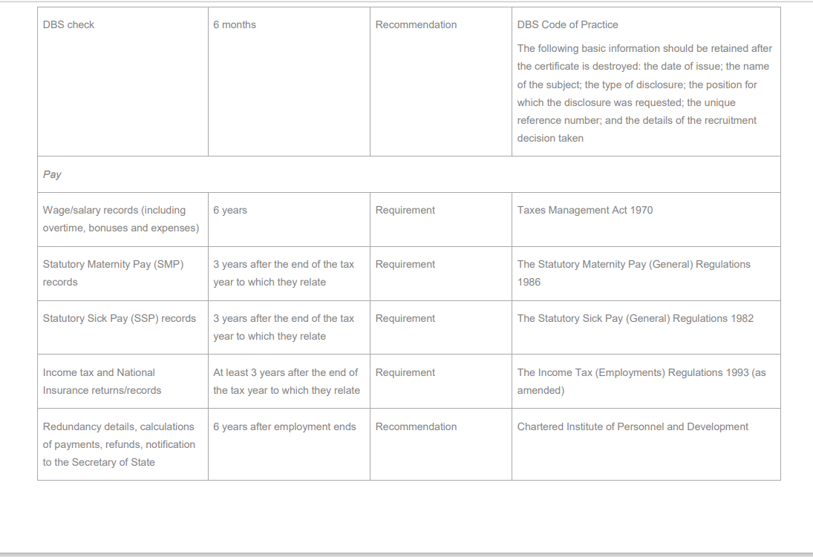
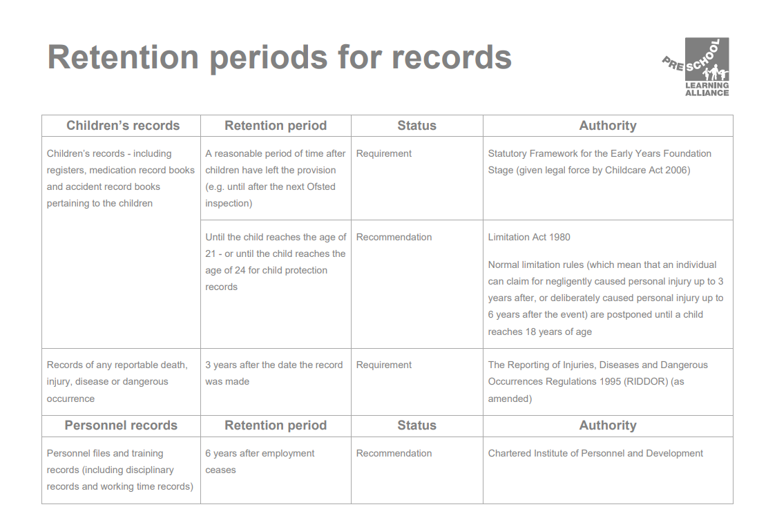
Appendix 1- Retention of data guidelines

